Keyword

Keywords are reserved names whose meaning is already defined in computer memory called as keywords.

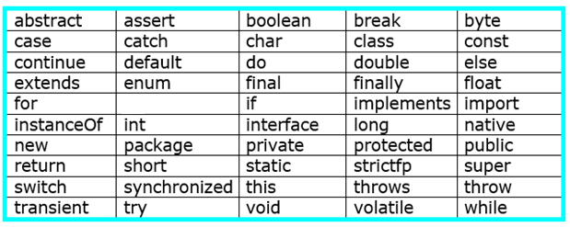

Data Types

Data types are used to represent type of data or information which will be stored into variable called as data types.

There are two types of data types.

* **Primitive’s data types**
* **Non primitive’s data types**

**Fig. Classification of data types**

1. byte- it store the number range from -128 to 127.It has default size is 1 byte and default value is 0. Example- byte b=5.

1. short- it store the number range from -32768 to 32767. It has default size is 2 byte and default value is 0.Example short s=2.
2. int- it store the number range from -2147483648 to 2147483647. It has default size is 4 byte and default value is 0. Example int a=5;
3. long- it store the number range from -9223372036854775808 to 9223372036854775807. It has default size is 8 byte and default value is 0. Example- long b=50000.
4. float- it store the number range from 3.4e−038 to 3.4e+038. It has default size is 4 byte and default value is 0.0f. Example float s=3.45f.

1. double- it store the number range from 1.7e−308 to 1.7e+308.It has default size is 8 byte and default value is 0.0d. Example double d=34.67d.
2. boolean- it store the value in true or false. default value is false.
3. char- it is used to store the single character. which is enclosed within single quotes only. Example        char c= 'k';

Difference between primitives and Non-primitives data types

Data types sizes and its default values as-

Char-blank

Float-0.0

Double-0.0